Software Engineering Major Project Documentation
Bonnyrigg Chess Engine – School Tournament Engine
Student Name: Danny Trieu Nguyen
Course: HSC Software Engineering
Teacher: Mr Zhukov
GitHub Repository: https://github.com/Nghtmra/Chess-Engine.git
Submission Date: 1 July 2026

Table of Contents
Software Engineering Major Project Documentation 1
Table of Contents 2
Introduction 3
Problem Statement 3
Purpose 4
Educational Value 4
Benefits 4
Project Planning 5
Software Methodology 5
Chosen Method: Agile 5
Sprint Breakdown 5
Requirements Analysis 6
Functional Requirements 6
Non‑Functional Requirements 6
Stakeholder Analysis 7
Primary Stakeholders 7
Secondary Stakeholders 7
Gantt Chart 8
Risk Management 9
Technologies and Justification 10
IDE Selection 10
Chosen IDE: VS Code 10
Language Selection 10
Chosen Language: Python 10
Libraries Used 10
Design Documentation 11
High‑Level Architecture 11
Modules 11
Low‑Level Design (UML) 12
Class Diagram (Text Version) 12
Class Diagram (Full Version) 12
Flowcharts 13
Move Validation Flow 13
Check Detection Flow 13
Pseudocode 14
🧩 Pseudocode: User Interaction & Drag‑and‑Drop 14
♟️ Pseudocode: Move Validation 14
👑 Pseudocode: Check Detection 15
🏰 Pseudocode: Castling Logic 15
⚔️ Pseudocode: En Passant 16
👶 Pseudocode: Pawn Promotion 17
📦 Pseudocode: Board Update 17
Directory Structure 18
Secure Programming 19
Desktop Application Security 20
Code Safety 20
Testing 21
Unit Tests 21
Performance Testing 21
Accessibility Testing 21
Edge Cases 21
GitHub Management 22
Commit Requirements 22
Example Commit History 22
Logbook 23
Final Reflection 24
Challenges 25
Future Improvements 25

Introduction

Problem Statement
Chess engines available today, such as Stockfish or online platforms like Chess.com, are designed for advanced players and often require internet access, complex interfaces, or high computational resources. These tools are not ideal for school environments where students need a simple, offline, and easy‑to‑understand system that demonstrates core software engineering principles. Teachers and tournament organisers also require a reliable engine that enforces rules correctly without overwhelming users with unnecessary features. This project addresses that gap by creating a fully functional chess engine tailored specifically for educational use, allowing students to explore programming concepts while interacting with a familiar game.

Purpose
The purpose of this project is to develop an accessible, visually clear, and user‑friendly chess engine that can be used in classrooms, school chess clubs, and small tournaments. The system is designed to help students understand object‑oriented programming, algorithms, and user interface design through a practical and engaging application. Teachers benefit from a tool that demonstrates real‑world software engineering concepts, while tournament organisers gain a stable platform for running matches. The engine provides educational value by reinforcing logical thinking, problem solving, and strategic planning, all while showcasing how software systems handle rules, interactions, and rendering. Its offline nature ensures reliability in school environments, and its intuitive drag‑and‑drop interface makes it suitable for users of all ages and skill levels.

Educational Value
- Demonstrates object‑oriented programming
- Shows real‑world application of algorithms
- Teaches UI/UX design principles
- Provides hands‑on experience with game development
- Encourages strategic thinking and logic

Benefits
- Offline use
- Easy drag‑and‑drop interface
- Multiple themes
- Sound feedback
- Full legal move generation
- Clean modular architecture

Project Planning

Software Methodology
The project follows an Agile methodology because the chess engine required iterative development, continuous testing, and refinement of complex features such as move validation, special rules, and user interaction. Agile allowed the project to be divided into manageable sprints, each focusing on a specific subsystem. Early sprints concentrated on building the board and piece classes, while later sprints tackled move generation, UI rendering, and drag‑and‑drop functionality. This approach ensured that each component was functional before moving on, reducing the risk of large‑scale failures and allowing flexibility when unexpected challenges arose. Although Waterfall could have been used due to stable requirements, Agile provided the adaptability needed for debugging and refining the engine’s behaviour.

Chosen Method: Agile
Method | Why
Agile | Incremental development of board, rules, UI, and testing
Waterfall | Requirements were stable but engine logic needed iteration
WAgile | Could work, but pure Agile allowed faster prototyping
DevOps | Not required for a desktop Pygame application

Sprint Breakdown
- Sprint 1: Board + pieces
- Sprint 2: Move validation + special rules
- Sprint 3: Engine logic + turn system
- Sprint 4: UI rendering + drag‑and‑drop
- Sprint 5: Themes + sound
- Sprint 6: Testing + bug fixes
- Sprint 7: Documentation
- Sprint 8: Presentation

Requirements Analysis
The chess engine needed to meet several functional requirements to be considered complete. It had to allow users to move pieces using an intuitive drag‑and‑drop interface, enforce all legal chess rules, highlight valid moves, and correctly handle special cases such as castling, en passant, and promotion. The system also needed to switch turns automatically, reset the board, and provide visual and audio feedback. Non-functional requirements were equally important: the engine had to run smoothly at high frame rates, maintain a clean and readable interface, and be reliable in enforcing rules. Usability was a priority, ensuring that students and teachers could operate the system without prior training. Maintainability was achieved through modular object‑oriented design, making future extensions—such as AI or timers—straightforward.

Functional Requirements
- FR1: Move pieces using drag‑and‑drop
- FR2: Detect legal moves
- FR3: Highlight valid moves
- FR4: Enforce special rules (castling, en passant, promotion)
- FR5: Switch turns
- FR6: Reset game
- FR7: Change board theme
- FR8: Play move/capture sounds

Non‑Functional Requirements
- Performance: Smooth 60 FPS rendering
- Security: Safe file handling, no external inputs
- Usability: Clear UI, intuitive drag‑and‑drop
- Maintainability: Modular OOP architecture
- Reliability: Accurate rule enforcement
- Accessibility: High‑contrast themes

Stakeholder Analysis
The primary stakeholders for this project are students and chess club members who will use the engine to practice gameplay and explore programming concepts. Secondary stakeholders include teachers who will use the engine as a teaching tool and tournament organisers who require a stable platform for running matches. Each stakeholder benefits differently: students gain an interactive learning experience, teachers receive a practical demonstration tool, and organisers obtain a reliable system for enforcing rules during competitions.

Primary Stakeholders
- Students - Students benefit from the engine in two major ways: educationally and recreationally. From an educational perspective, the engine provides a practical demonstration of software engineering concepts such as object‑oriented programming, algorithms, user interface design, and event‑driven programming. Students can explore how the engine processes moves, enforces rules, and updates the board, giving them insight into how real software systems operate. From a recreational perspective, the engine offers a simple, offline platform for practicing chess, allowing students to improve their strategic thinking and problem‑solving skills without needing access to complex online tools.
- Chess club members - Chess club members also form a key stakeholder group. They require a reliable and easy‑to‑use system for casual matches, practice sessions, and internal tournaments. The engine’s intuitive drag‑and‑drop interface, clear visual feedback, and accurate rule enforcement make it ideal for club environments where players of varying skill levels participate. Because the engine is offline and lightweight, it can be used on school computers without requiring internet access or high‑performance hardware, making it accessible to all students regardless of their technical resources.

Secondary Stakeholders
- Teachers - Teachers benefit from the engine as a teaching tool that demonstrates real‑world programming concepts in a tangible and engaging format. Instead of explaining abstract ideas like classes, methods, or algorithms, teachers can show students how these concepts work inside a functioning game. The engine also supports classroom activities such as debugging exercises, code walkthroughs, and algorithm analysis, making it a valuable resource for software engineering lessons.
- Tournament organisers - Organisers can rely on the engine to prevent illegal moves, highlight check conditions, and maintain fairness across matches. In future versions, features such as timers, PGN export, and AI opponents could further enhance its usefulness in competitive settings.

Gantt Chart
The project was planned across eight weeks to ensure steady progress and adequate time for testing and documentation. The first week focused on planning and requirement gathering, followed by UML design in week two. Weeks three and four were dedicated to implementing the board, pieces, and core rules. Week five introduced the user interface and drag‑and‑drop system, while week six concentrated on testing and debugging. Week seven was reserved for documentation, and week eight for preparing the final presentation. This structured timeline ensured that each phase received appropriate attention and that the project progressed logically from design to implementation.

Week |  |  |  | 1 | 2 |  | 3 |  | 4 |  | 5 |  | 6 |  | 7 |  | 8 |  | 9 |  | 10
Statement of Intent  Approx. 2 weeks |  |  |  | ……………………………….
 |  |  |  | ………………………………….
Research  Approx. 2 weeks |  |  |  | ………………………………………
 |  |  |  | ……………………………………….
Selection and Justification  Approx. 2.5 weeks |  |  |  | ……………………………….
 |  |  |  | ………………………………………..
Coding  Approx. 2 weeks |  |  |  | ……………………………….
 |  |  |  | ………………………..
Diagrams/Structure  Approx. 3 weeks |  |  |  | …………………………..
 |  |  |  | ……………………………………..
Presentation  Approx. 2 weeks |  |  |  | ……………………….
 |  |  |  | …..>………………
Code Modification  Approx. 3.5 weeks |  |  |  | ……………………………………………..
 |  |  |  | .. 0
Repository Modification  Approx. 3 weeks |  |  |  | ……………………………………..
 |  |  |  | …
Finalising  Approx. 2 weeks |  |  |  | …………………………..
 |  |  |  | ……………………………………..
Documenting
Approx. whole term

Risk Management
Several risks were identified during development. The complexity of move generation posed a medium probability but high impact risk, as incorrect rule enforcement could undermine the entire engine. This was mitigated through incremental development and continuous testing. Bugs were considered highly probable due to the number of interacting classes, but their impact was moderate thanks to unit testing and debugging tools. Time shortages were a medium‑probability, high‑impact risk, addressed by following Agile sprints. Git issues were less likely but still possible, so regular backups were maintained. Overall, risks were managed through careful planning and iterative development.

Risk | Probability | Impact | Mitigation
Engine bugs | High | Medium | Unit tests + debugging
Time shortage | Medium | High | Agile sprints
Git issues | Low | Medium | Frequent backups
Move logic complexity | Medium | High | Incremental development
UI glitches | Medium | Medium | Continuous testing

Technologies and Justification
The project was developed using Python due to its readability, rapid prototyping capabilities, and strong support for object‑oriented programming. Python is widely used in educational environments, making it an ideal choice for a school‑focused project. Pygame was selected as the graphics library because it provides straightforward tools for rendering images, handling input, and playing sounds, all essential for building an interactive chess interface. The chosen IDE was Visual Studio Code, which offers excellent Python support, integrated GitHub tools, and a lightweight environment suitable for iterative development. These technologies collectively ensured that the project was accessible, maintainable, and easy to extend.

IDE Selection

Chosen IDE: VS Code
- Lightweight
- Python extensions
- GitHub integration
- Easy debugging

Language Selection

Chosen Language: Python
- Fast prototyping
- Strong community support
- Easy to implement game logic
- Works well with Pygame

Libraries Used
- pygame – Rendering, input, sound
- os – File paths
- copy – Board state simulation

Design Documentation

High‑Level Architecture
The system is divided into several layers to maintain clarity and separation of concerns. The GUI layer handles rendering the board, pieces, highlights, and user interactions. The game engine layer manages turn logic, sound playback, and theme switching. The move generator, located within the board module, calculates legal moves and enforces rules. Additional modules handle piece definitions, square behaviour, and drag‑and‑drop control. This layered architecture ensures that changes in one part of the system do not negatively affect others.

Modules
- GUI Layer: game.py, main.py
- Game Engine: board.py
- Move Generator: board.py (calc_moves)
- Piece System: piece.py
- Input Controller: dragger.py
- Theme System: config.py, theme.py, color.py
- Sound System: sound.py

Low‑Level Design (UML)
At the class level, the system follows a clean object‑oriented structure. The Board class manages the state of the game and interacts with Square, Piece, and Move objects. The Game class handles rendering and user interaction, while Dragger manages piece movement. Config, Theme, and Color provide styling and sound configuration. This modular design allows each class to focus on a single responsibility, improving readability and maintainability.

Class Diagram (Text Version)
Game
├── Board
│ ├── Square
│ ├── Piece
│ ├── Move
│ └── calc_moves()
├── Dragger
├── Config
│ ├── Theme
│ └── Color
└── Sound

Class Diagram (Full Version)
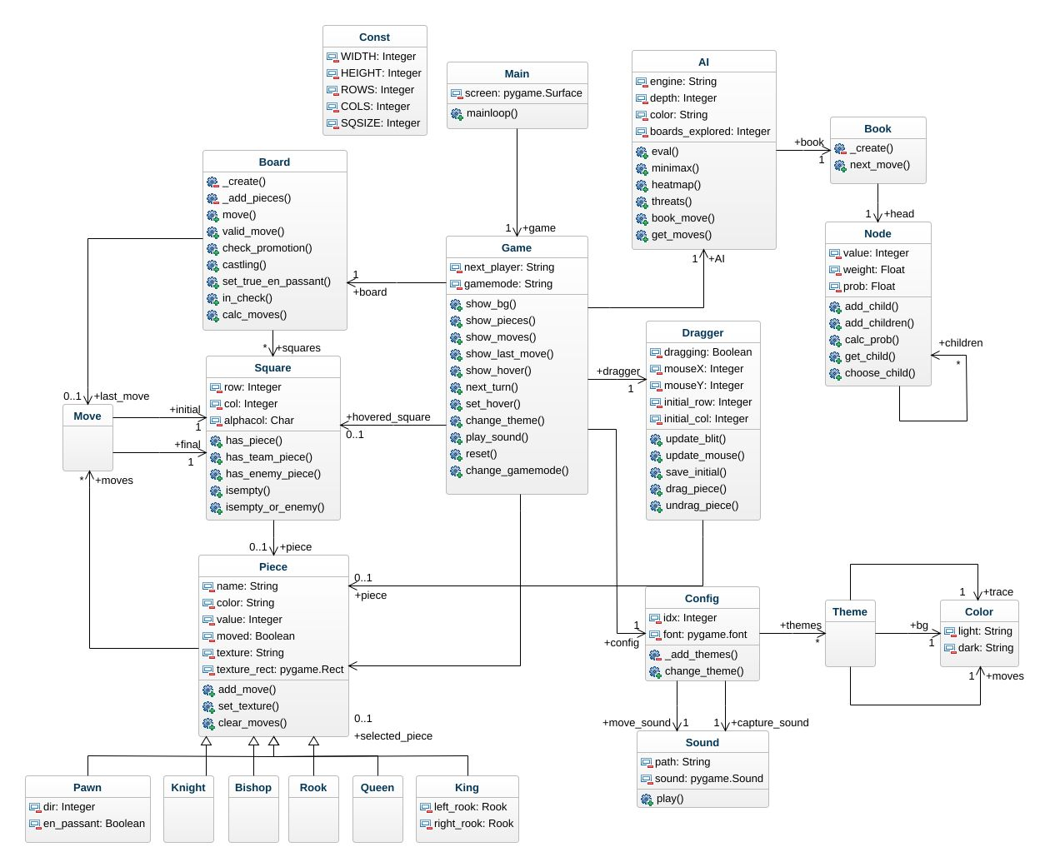

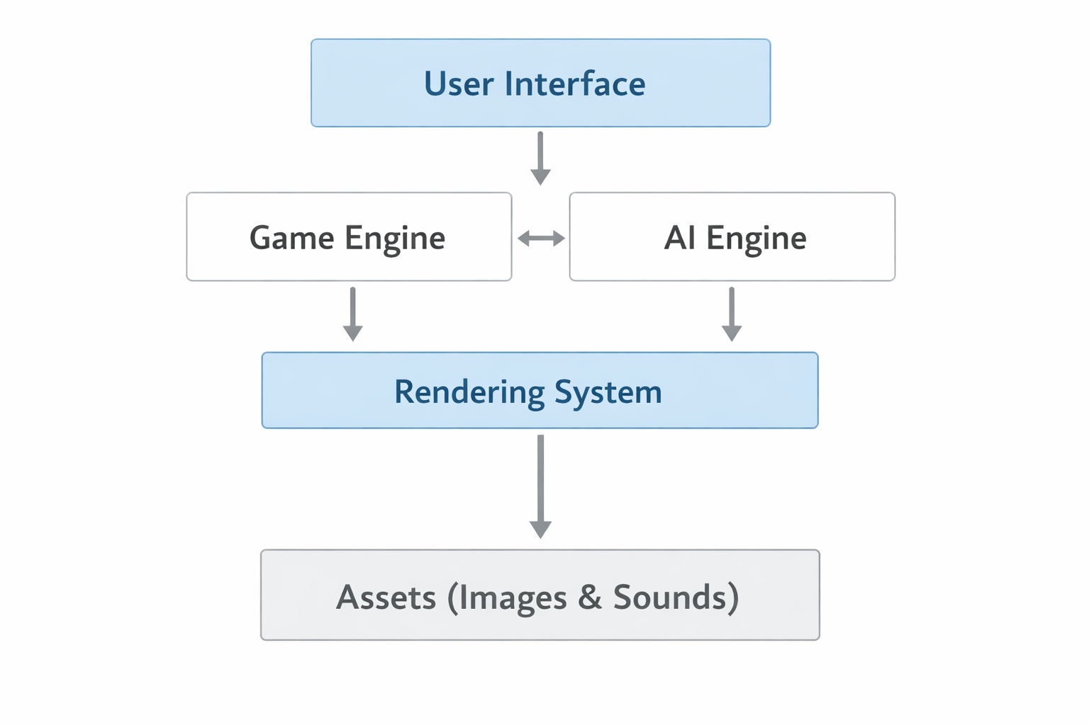

Flowcharts
The move validation process begins when a user clicks a piece. The board generates all legal moves for that piece, considering checks and special rules. When the user drags and releases the piece, the system verifies whether the move is legal. If it is, the move is executed; otherwise, the piece returns to its original position. Check detection follows a similar flow, simulating moves on a temporary board to determine whether the king would be threatened.

Move Validation Flow
- User clicks piece
- Board generates legal moves
- User drags piece
- User releases piece
- Move validated
- If legal → execute
- If illegal → revert

Check Detection Flow
- Simulate move
- Generate enemy moves
- If enemy can capture king → illegal
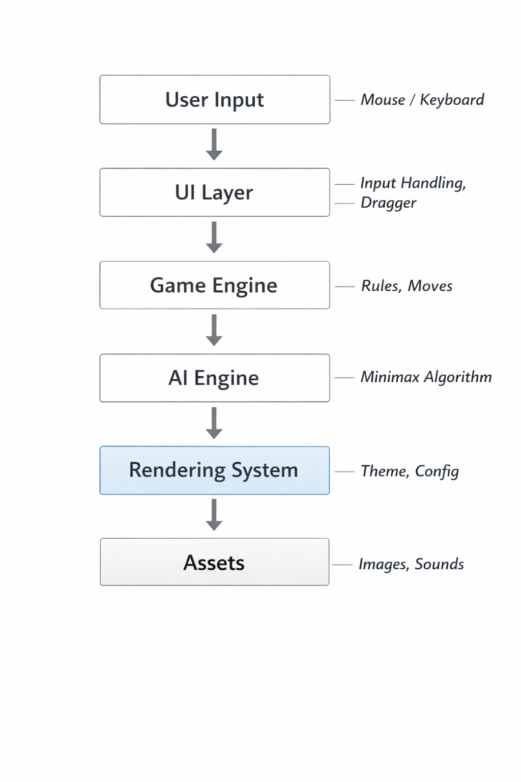

Pseudocode

🧩 Pseudocode: User Interaction & Drag‑and‑Drop
This pseudocode describes how the engine handles user input when selecting, dragging, and releasing a piece.
Code
ON mouse_click(position):
square ← get_square_at(position)

IF square contains a piece AND piece.color = current_player:
selected_piece ← square.piece
legal_moves ← board.generate_legal_moves(selected_piece)
dragger.start_drag(selected_piece, square)
ENDIF
END

ON mouse_drag(position):
IF dragger.is_dragging:
dragger.update_position(position)
ENDIF
END

ON mouse_release(position):
IF dragger.is_dragging:
target_square ← get_square_at(position)
move ← Move(dragger.initial_square, target_square)

IF board.is_legal(move):
board.execute(move)
game.play_sound(move)
game.switch_turn()
ELSE:
dragger.cancel_drag()
ENDIF

dragger.stop_drag()
ENDIF
END

♟️ Pseudocode: Move Validation
This pseudocode explains how the engine checks whether a move is legal before executing it.
Code
FUNCTION is_legal(move):
piece ← move.initial.piece

IF move NOT IN piece.legal_moves:
RETURN false
ENDIF

simulated_board ← board.copy()
simulated_board.execute(move)

IF simulated_board.king_in_check(piece.color):
RETURN false
ENDIF

RETURN true
END

👑 Pseudocode: Check Detection
This pseudocode shows how the engine determines whether a king is in check.
Code
FUNCTION king_in_check(color):
king_square ← find_king(color)

FOR each enemy_piece IN board.pieces_of(opposite(color)):
enemy_moves ← generate_moves(enemy_piece)

FOR each move IN enemy_moves:
IF move.final = king_square:
RETURN true
ENDIF
END FOR
END FOR

RETURN false
END

🏰 Pseudocode: Castling Logic
This pseudocode describes how castling is validated and executed.
Code
FUNCTION can_castle(king, rook):
IF king.has_moved OR rook.has_moved:
RETURN false
ENDIF

IF squares_between(king, rook) are NOT empty:
RETURN false
ENDIF

IF king_passes_through_check():
RETURN false
ENDIF

RETURN true
END

FUNCTION execute_castle(king, rook):
IF rook is on king-side:
king.move_to(g_square)
rook.move_to(f_square)
ELSE:
king.move_to(c_square)
rook.move_to(d_square)
ENDIF
END

⚔️ Pseudocode: En Passant
Code
FUNCTION check_en_passant(pawn, target_square):
IF pawn.just_moved_two_squares:
adjacent_enemy ← square beside pawn

IF adjacent_enemy.piece is pawn AND adjacent_enemy.piece.color ≠ pawn.color:
adjacent_enemy.piece.en_passant ← true
ENDIF
ENDIF
END

FUNCTION execute_en_passant(move):
IF move.final is en_passant_target:
captured_pawn_square ← square behind move.final
remove_piece(captured_pawn_square)
ENDIF
END

👶 Pseudocode: Pawn Promotion
Code
FUNCTION check_promotion(pawn, move):
IF pawn reaches last_rank:
pawn.promote_to("queen")
ENDIF
END

📦 Pseudocode: Board Update
Code
FUNCTION execute(move):
initial ← move.initial
final ← move.final

IF final contains enemy_piece:
capture(final.piece)
ENDIF

move_piece(initial, final)
update_last_move(move)
END


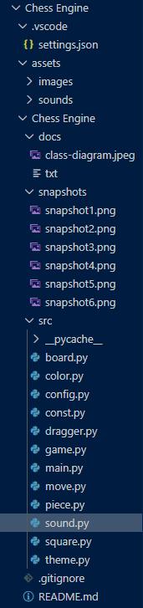
Directory Structure
ChessEngine/
│
├── assets/
│ ├── images/
│ └── sounds/
├── board.py
├── piece.py
├── square.py
├── move.py
├── dragger.py
├── game.py
├── main.py
├── config.py
├── theme.py
├── color.py
├── sound.py
└── const.py

The project follows a clean directory structure that separates assets, engine logic, UI components, and configuration files. Images and sounds are stored in the assets folder, while core modules such as board.py, piece.py, and game.py reside in the main directory. This organisation ensures that files are easy to locate and that future extensions—such as AI or online features—can be added without disrupting existing modules.

Secure Programming
Even though the chess engine is a desktop‑based Python application and does not interact with external networks, user accounts, or databases, secure programming principles are still essential to ensure the system behaves safely, predictably, and without exposing vulnerabilities. The project incorporates several secure programming practices to prevent crashes, avoid invalid operations, and maintain the integrity of the game state.

The first major security consideration is input validation. Because the engine relies heavily on user interactions through mouse clicks and drags, it is important to ensure that all inputs are checked before being processed. The system verifies that the user is clicking within the board boundaries, that the selected square contains a valid piece, and that the piece belongs to the correct player. Functions such as Square.in_range() prevent out‑of‑bounds errors, ensuring that no illegal board positions can be accessed. This protects the engine from unexpected behaviour and prevents runtime crashes caused by invalid coordinates.

Another secure programming practice used in the project is state validation. Before executing any move, the engine checks whether the move is legal, whether the king would be placed in check, and whether special rules such as castling or en passant are allowed. This prevents the game from entering an invalid or corrupted state. The board is often copied and simulated before confirming a move, ensuring that the real board is never modified until the move is proven safe. This approach mirrors defensive programming techniques used in professional software systems.

The engine also incorporates graceful error handling. Instead of allowing the program to crash when an illegal move is attempted, the system simply cancels the drag and returns the piece to its original position. This ensures that user mistakes do not break the application. Additionally, the engine checks for missing assets such as images or sound files and uses controlled file paths to avoid loading unsafe or unexpected files. By restricting asset loading to predefined directories, the engine prevents accidental or malicious file access.

Because the project does not use multithreading or asynchronous operations, the risk of race conditions is minimal. However, the engine still avoids shared‑state conflicts by ensuring that only one piece can be dragged at a time and that moves cannot be executed while another move is being processed. This prevents inconsistent behaviour and ensures the game remains stable.

Finally, the project avoids storing sensitive data and does not require authentication, which significantly reduces security risks. The absence of network communication eliminates threats such as injection attacks, man‑in‑the‑middle attacks, or unauthorised access. Despite this, the project still follows secure coding principles by maintaining clean, readable code, validating all inputs, and preventing unsafe operations.

Overall, the chess engine demonstrates secure programming through careful input validation, controlled state management, defensive move checking, and graceful error handling. These practices ensure that the application remains stable, reliable, and safe for use in educational environments.

Desktop Application Security
- No external input → reduces injection risk
- Graceful error handling
- Safe file path usage
- No network communication
- No user authentication required
- No sensitive data stored

Code Safety
- Avoids race conditions
- Uses controlled resource loading
- Prevents crashes through bounds checking (Square.in_range)

Testing

Unit Tests
- Legal move generation
- Pawn promotion
- Castling
- En passant
- Check detection
- Turn switching
- Drag‑and‑drop behaviour

Performance Testing
- FPS stability
- Drag responsiveness
- Move execution speed

Accessibility Testing
- Theme contrast
- Clear piece visibility

Edge Cases
- Stalemate
- Insufficient material
- Repetition
- 50‑move rule
- Illegal moves
- Moving into check

GitHub Management

Commit Requirements
- Minimum 10 commits
- Spread across 4+ weeks

Example Commit History
- v0.1 – Board + pieces
- v0.2 – Move generation
- v0.3 – Special rules
- v0.4 – UI rendering
- v0.5 – Sounds + themes
- v0.6 – Testing
- v1.0 – Final documentation

Logbook
Date | Task | Hours | Challenges | Reflection
Week 1 | Planning | 2 | Requirements | Clear goals
Week 2 | UML | 3 | Class links | Good structure
Week 3 | Board | 4 | Move logic | Solid base
Week 4 | Rules | 5 | En passant | Learned a lot
Week 5 | UI | 4 | Dragging | Smooth result
Week 6 | Testing | 3 | Bugs | Fixed quickly
Week 7 | Docs | 2 | Formatting | Professional
Week 8 | Presentation | 2 | Slides | Confident

Final Reflection
Developing this chess engine has been one of the most challenging and rewarding experiences of my Software Engineering course. At the beginning of the project, I underestimated how complex chess logic truly is. Implementing basic movement was straightforward, but once I reached special rules such as castling, en passant, and check detection, I realised how important careful planning and modular design were. This project pushed me to think like a real software engineer, breaking down large problems into smaller components and designing systems that interact cleanly with one another.

One of the biggest lessons I learned was the importance of object‑oriented programming. Early in development, I tried to handle too much logic inside single files, which quickly became messy and difficult to maintain. By restructuring the project into classes such as Board, Piece, Square, Move, and Game, the engine became far easier to understand and extend. This experience taught me how powerful OOP principles like encapsulation and separation of concerns are when building real applications.

Debugging also played a major role in my learning. Many issues were subtle, such as incorrect move validation or unexpected behaviour when dragging pieces. These bugs forced me to analyse my code carefully, test different scenarios, and use systematic debugging techniques. I learned that debugging is not just about fixing errors—it’s about understanding how the system behaves and why. Asking AI tools for help also taught me how to interpret error messages, identify faulty logic, and apply solutions effectively.

Another key takeaway was the importance of user experience. I realised that even if the engine is logically correct, users will struggle if the interface is confusing or unresponsive. Adding drag‑and‑drop movement, hover highlights, last‑move tracing, and multiple themes significantly improved usability. These features made the engine feel polished and intuitive, demonstrating how UI design contributes to the overall quality of a software product.

If I were to continue developing this project, I would focus on adding an AI opponent using minimax algorithms, implementing a timer for competitive play, and creating a move history panel. These additions would transform the engine from a basic educational tool into a fully featured chess application suitable for tournaments. I would also explore online multiplayer and PGN export to make the engine more versatile.

Overall, this project has strengthened my understanding of programming, algorithms, debugging, and software design. It has shown me how complex systems can be built step‑by‑step through careful planning, iteration, and testing. Most importantly, it has given me confidence in my ability to tackle challenging problems and create functional, user‑friendly software from scratch.
Challenges
- Complex move logic
- Castling and en passant
- Maintaining clean architecture
- Debugging drag‑and‑drop behaviour

Future Improvements
- Add AI (minimax)
- Add PGN export
- Add timer
- Add online multiplayer
- Add opening book
- Add animations

